**The Mini Project entitled**

**PRESSURE COOKER WHISTLE SENSOR**

Submitted in partial fulfillment of academic requirements for the award of the degree of

Bachelor of Engineering (Computer Science and Engineering)

**By**

**KRISHNA SANKETH CHACHIDAK 2451-15-733-050**

**SHIVA PRASAD JUPALLY 2451-15-733-054**

**HARSHITH JADI 2451-15-733-055**



**Department of Computer Science and Engineering**

**M.V.S.R. ENGINEERING COLLEGE**

**(Affiliated to Osmania University & Recognized by AICTE)**

**Nadergul, Saroor Nagar Mandal, Hyderabad – 501 510**

**2017-18.**

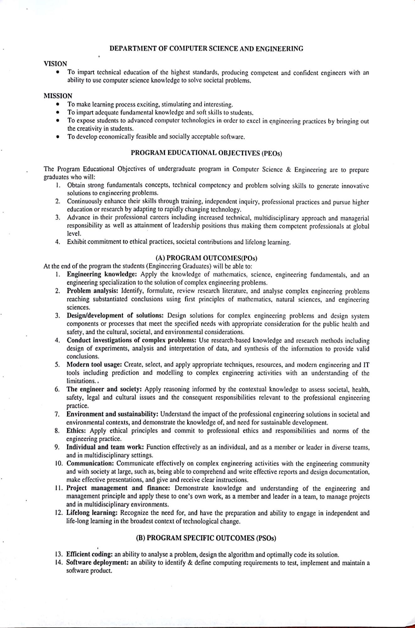

**Department of Computer Science and Engineering**

**M.V.S.R. ENGINEERING COLLEGE**

**(Sponsored by Matrusri Education Society, Estd. 1980)**

**(Affiliated to Osmania University & Recognized by AICTE)**

**Nadergul, Saroor Nagar Mandal, Hyderabad – 501 510**



**CERTIFICATE**

This is to certify that the project entitled **“PRESSURE COOKER WHISTLE SENSOR”,** is being submitted by **Mr.CH.KRISHNA SANKETH** bearing H.T.No **2451-15-733-050**, **Mr.J.SHIVA PRASAD** bearing H.T.No **2451-15-733-054** AND **Mr.J.HARSHITH** bearing H.T.No **2451-15-733-055** in partial fulfillment of academic requirements for the award of the degree of BACHELOR OF ENGINEERING in COMPUTER SCIENCE AND ENGINEERING from MVSR Engineering College, affiliated to OSMANIA UNIVERSITY, is a record of bonafide work carried out by him under the guidance and supervision of the faculty (CSED). The results embodied in this project report have not been submitted to any other University or Institute for the award of any degree or diploma to the best of my knowledge and belief.

|  |  |  |
| --- | --- | --- |
| Guide |  | Project Coordinator(s) |
| **N.Sabitha**  Assistant Professor,  Department of CSE,  MVSR Engineering College. |  | **D.Sirisha&T.Sujanavan**  Assistant Professors,  Department of CSE,  MVSR Engineering College. |
|  |  |  |
|  |  |  |
|  |  |  |

**ACKNOWLEDGMENT**

I take this opportunity to express my profound and sincere gratitude to all those who helped us in carrying out this project successfully.

At the very outset, I am thankful to our principal Sri **Dr.G.Kanaka Durga** and **Dr.Akhil Khare**, Professor and Head, Department of Computer Science and Engineering, MVSR Engineering College, Hyderabad for their consent to do the project work as a part of our B.E Degree (CSE). We thank them for their valuable suggestions and advice throughout our stay at the college, during our project work.

I would like to thank our Internal Project Guide **Mrs.N.Sabitha** , Assistant Professor, Department of Computer Science and Engineering, MVSR Engineering College for his/her useful suggestions, guidance and encouragement

We also thank our mentors **Mrs D.Sirisha** ,**Mr T.Sujanavan,** Assistant Professors, Department of Computer Science and Engineering, MVSR Engineering College, for their constant support and feedback.

.

We thank the teaching and non-teaching staff of CSE for extending their support.

Finally we are thankful to our parents for their cooperation and support throughout all endeavors in our life.

KRISHNA SANKETH CHACHIDAK 2451-15-733-050

SHIVA PRASAD JUPALLY 2451-15-733-054

HARSHITH JADI 2451-15-733-055

**ABSTRACT**

As most of us know that women are experts in Multi-tasking when it comes to household works. Pressure cooker is being used as one of the appliance from many decades. Especially in India, Pressure cooker will be used in every 7 out of 10 homes. But it takes some time to cook food. If we go on focus on other work and off it after getting more whistles, food may get spoiled. So, there would be a buzzer, which warns us to off the cooker after getting enough number of whistles. By hearing that we can go to kitchen and off it even if we are some meters away from kitchen. So our project will be based on around sensing where it counts the number of whistles and display respective number of LED's. Rings a buzzer when the whistle count has exceeded more than 4.

**LIST OF CONTENTS**

**S.NO CHAPTER PAGE NO**

**1 INTRODUCTION 12**

**1.1. PROBLEM STATEMENT 12**

**1.2. SCOPE 12**

**1.3. OBJECTIVES 12**

**2 LITERATURE SURVEY 13**

**2.1. MICROCONTROLLER 13**

**2.2. SENSORS 14**

**2.2.1. SOUND SENSOR MODULE 14**

**2.3. ARDUINO IDE 15**

**3 SYSTEM ARCHITECTURE**

**3.1. LAYOUT OF DUAL LOCKING WITH 17**

**WI-FI CONTROLLED SECURITY**

**4 IMPLEMENTATION**

**4.1. SETTING UP THE ENVIRONMENT 18**

**4.2. SOURCE CODE 18**

**5 TESTING 20**

**6 CONCLUSION**

**6.1. CONCLUSION 25**

**6.2. FUTURE ENHANCEMENTS 26**

**REFERENCES 26**

**LIST OF FIGURES**

**S.NO FIG.NO TITLE PAGE.NO**

**1 2.1 MICROCONTROLLER 13**

**2 2.2.1 SOUND SENSOR MODULE 14**

**3 2.3.1 ARDUINO IDE 15**

**4 2.3.2 BLINK EXAMPLE IN 16**

**ARDUINO IDE**

**5 3.1.1 LAYOUT DIAGRAM FOR 17**

**DUAL LOCKING SYSTEM**

**WITH WI-FI CONTROLLED**

**SECURITY**

**6 5.1 BASIC LOOK OF THE PROJECT 22**

**7 5.2 WHEN THE FIRST WHISTLE IS**

**DETECTED 23**

**8 5.3 WHEN THE SECONDWHISTLE IS 23**

**DETECTED**

**9 5.4 WHEN THE THIRD WHISTLE IS**

**DETECTED 24**

**10 5.5 AFTER THE LAST WHISTLE, 24**

**BUZZER ACTIVATES**

**CHAPTER-1**

**INTRODUCTION**

Pressure cooker sensor is an IOT project. The base foundation our project arose by a question “Why to count the number of whistles when we are grown up?”.In this modern Era everything is possible, so the basic idea of the project is to ease the attention towards the pressure cooker where it is difficult to count the number of whistles while doing another work.

**1.1.PROBLEM STATEMENT**

It is very much necessary to protect our belongings and possessions one of which is through sensors, resistors. But this procedure may not be reliable. Sensor evaluations are only 99.6% reliable. But what if you are one among those 0.04% ? You might lose counts. So there has to be something which increases the reliability of sensors authentication. We use resistors to resist and a red buzzer to indicate after 3 vessels.

**1.2. SCOPE**

Pressure cooker whistle sensor with sensor controlled system which increases the reliability of whistle count authentications can be used anywhere where there is a requirement of whistle count. It can be equipped in any system which has sensor and resistor authentication available in it. But it can be irritating at times when you are in a hurry. So it is suggested only to use this system.

**1.3.OBJECTIVES**

Pressure cooker whistle sensor with sensor controlled system is to increase the reliability of whistle count. The fact that sensor counts are not cent percent reliable throws out our possessions and valuables at risk. Pressure cooker whistle sensor system can be used anywhere, where you feel it is necessary to have exact count of whistles. The central objective is to save time and system reduces the man power in counting whistles. Third whistle which indicates green colour which is final state(food-cooked).So Imagine you are not there near cooker and when you want to inform a person who’s near cooker about the status of cooker through call or message we can make use of this system.

**CHAPTER-2**

**LITERATURE SURVEY**

**2.1. MICROCONTROLLER**

A **microcontroller** (or **MCU** for microcontroller unit) is a small computer on a single integrated circuit. In modern terminology, it is similar to system on a chip, but less sophisticated than, a  or SoC; an SoC may include a microcontroller as one of its components. A microcontroller contains one or more CPUs(processor cores) along with memory and programmable input/output peripherals.

Here we have used Node MCU microcontroller. **NodeMCU**  is an open source IOT platform. It includes firmware which runs on the ESP 8266 Wi-Fi SoC  from Express if Systems, and hardware which is based on the ESP-12 module. The term "NodeMCU" by default refers to the firmware rather than the dev kits. The firmware uses the Lua scripting language.

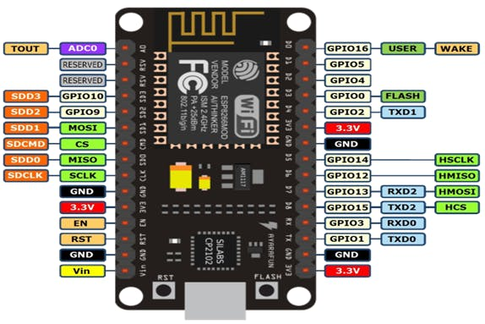**Fig.2.1.NodeMCU MicroController**

**2.2.SENSORS**

Sensor is a device, module, or subsystem whose purpose is to detect events or changes in its environment and send the information to other electronics, frequently a computer processor. A sensor is always used with other electronics, whether as simple as a light or as complex as a computer.

Sensors are used in everyday objects such as touch-sensitive elevator buttons (tactile sensor) and lamps which dim or brighten by touching the base, besides innumerable applications of which most people are never aware. With advances in micro machinery and easy-touse microcontroller platforms, the uses of sensors have expanded beyond the traditional fields of temperature, pressure or flow measurement

**2.2.1. SOUND SENSOR MODULE**

The sound sensor module provides an easy way to detect sound and is generally used for detecting sound intensity. This module can be used for security, switch, and monitoring applications. Its accuracy can be easily adjusted for the convenience of usage. It uses a microphone which supplies the input to an amplifier, peak detector and buffer. When the sensor detects a sound, it processes an output signal voltage which is sent to a microcontroller then per forms neccssary processing

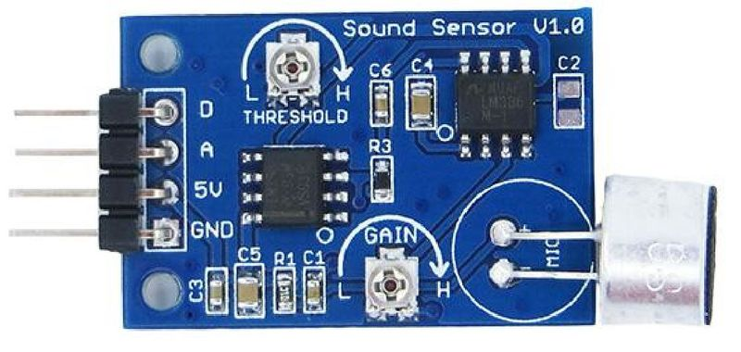

**Fig.2.2.1.SOUND SENSOR MODULE**

**2.3. IDE (Integrated Development Environment)**

IDE (Integrated Development Environment) that runs on your computer, used to write and upload computer code to the physical board. In this we use Arduino IDE for IOTt development. Arduino consists of both a physical programmable circuit board (often referred to as a microcontroller) and a piece of software. The IDE is a text editor-like program that allows you to write Arduino code. The open-source Arduino Software (IDE) makes it easy to write code and upload it to the board. It runs on Windows, Mac OS X, and Linux. The environment is written in Java and based on Processing and other open-source software. This software can be used with any Arduino board. The Arduino IDE supports the languages C and C++ using special rules of code structuring. The Arduino IDE supplies a software library from the Wiring project, which provides many common input and output procedures.



**2.3.1. Arduino IDE**

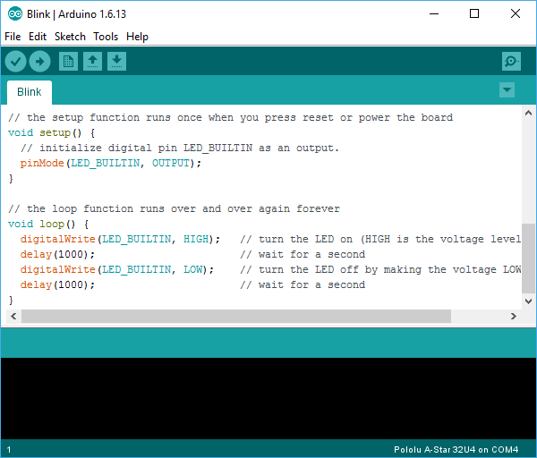

**2.3.2. Blink Example in Arduino IDE**

**CHAPTER-3 SYSTEM ARCHITECTURE**

**3.1. LAYOUT DIAGRAM FOR PRESSUR COOKER WHISTLE SENSOR**

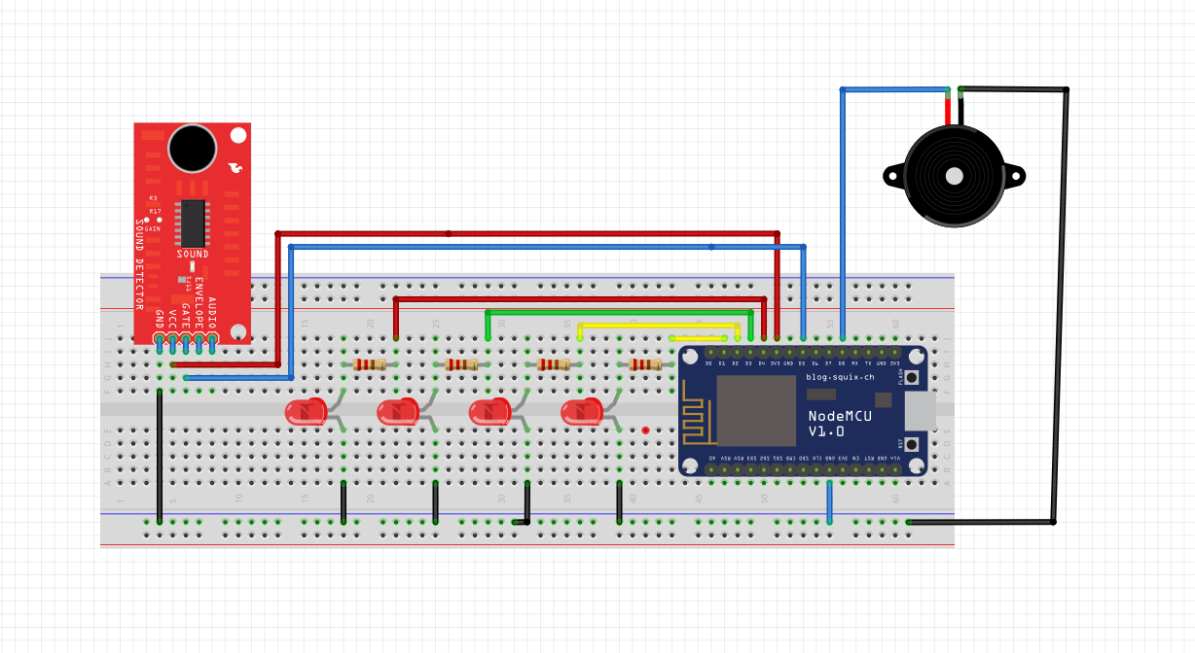

**Fig.3.1.1. Layout diagram for Pressur cooker whistle sensor**

1. The Sound Sensor Module which takes an input as the whistle, which is a sound.
2. The wires which acts as an interface between Sound Sensor Module and NodeMCU,the digital voltage provided by them module to the NodeMCU,it increases the count value increases the count value .
3. As the count value increases and becomes ‘1’, the first LED glows.
4. Since whistle sound delays for few seconds and the process delays and continues for 3-4
5. When the signal is passed for the last whistle ,the buzzer along with Red LED is set high.

**CHAPTER-4**

**IMPLEMENTATION**

**4.1.Setting up the Environment**

Firsly,let us see how to Install the Esp8266 support for the Arduino

* Firstly open Arduino IDE.
* Go to files and then click on preferences in Arduino IDE.
* Copy the below code in additional boards manager.

<http://arduino.esp8266.com/stable/package_esp8266com_index.json>

* Click OK to close preference tab.
* After completing the above steps, go to tools and board, and then select board manager.
* Navigate to ESP8266 by ESP8266 community and install the software of arduino
* Once all the above process is completed we are ready to program our ESP8266 with Arduino IDE

We have used NodeMCU as microcontroller and sound sensor module to detect the number of whistles which is presumed as a detector and an LED light glow is indicated as the whistle has been blown.

**4.2.Source Code**

int led1 = D4;

int led2 = D3;

int led3 = D2;

int led4 = D1;

int buzzer = D8;

int sensor = D5;

int value = 0;

int count = 0;

void setup() {

// put your setup code here, to run once:

Serial.begin(9600);

pinMode(led1,OUTPUT);

pinMode(led2,OUTPUT);

pinMode(led3,OUTPUT);

pinMode(led4,OUTPUT);

pinMode(buzzer,OUTPUT);

digitalWrite(buzzer,LOW);

digitalWrite(led2,LOW);

digitalWrite(led3,LOW);

digitalWrite(led4,LOW);

pinMode(sensor,INPUT);

}

void loop() {

// put your main code here, to run repeatedly:

value=digitalRead(sensor);

Serial.println(value);

if (value == 1 ) {

count = count + 1;

if ( count == 1 ) {

Serial.println("f1");

digitalWrite(led1,HIGH);

}

if ( count == 2 ) {

Serial.println("f2");

digitalWrite(led1,HIGH);

digitalWrite(led2,HIGH);

digitalWrite(led3,LOW);

digitalWrite(led4,LOW);

}

if ( count == 3 )

{

Serial.println("f3");

digitalWrite(led1,HIGH);

digitalWrite(led2,HIGH);

digitalWrite(led3,HIGH);

digitalWrite(led4,LOW);

}

if ( count == 4 ) {

Serial.println("f4");

digitalWrite(led1,HIGH);

digitalWrite(led2,HIGH);

digitalWrite(led3,HIGH);

digitalWrite(led4,HIGH);

digitalWrite(buzzer,HIGH);

}

if ( count == 5 ) {

Serial.println("f4");

digitalWrite(buzzer,HIGH); }

/*else {

Serial.println("off");

digitalWrite(led1,LOW);

digitalWrite(led2,LOW);

digitalWrite(led3,LOW);

digitalWrite(led4,LOW);

} }*/

}

delay(1000);

**CHAPTER-5 TESTING**

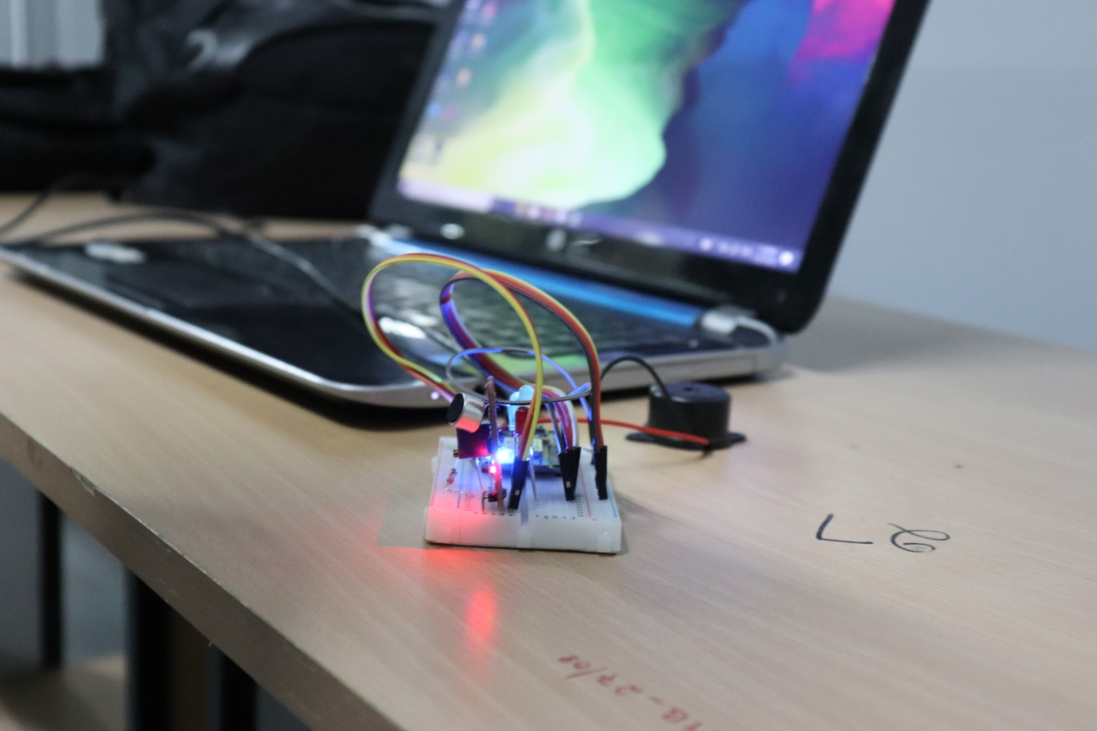

**Fig.5.1. Basic look of the project**

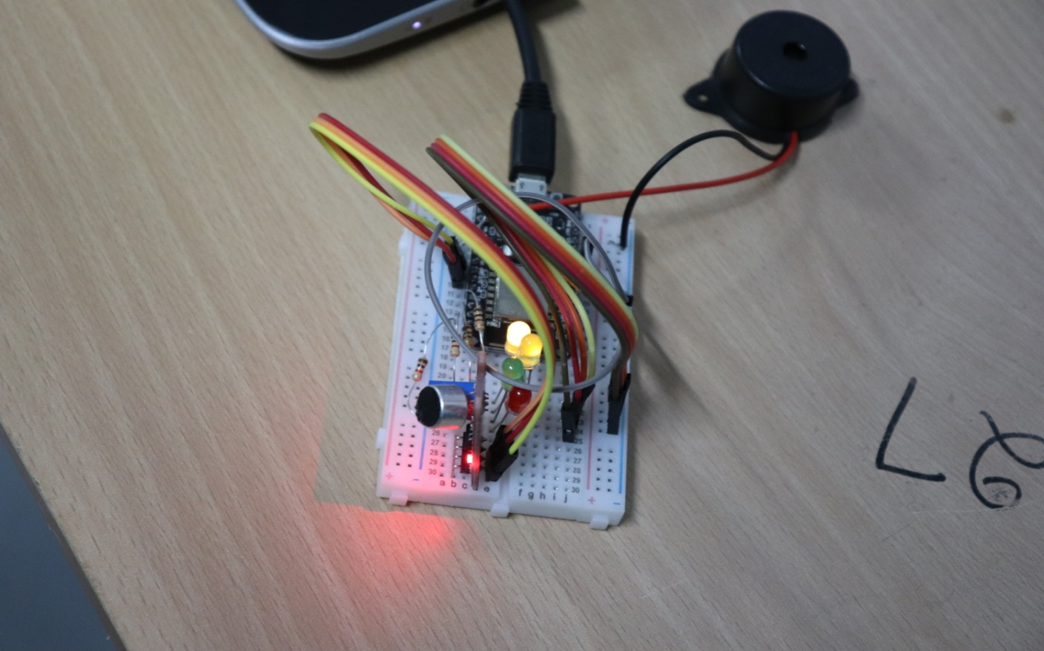

**Fig.5.2.When first whistle is detected**

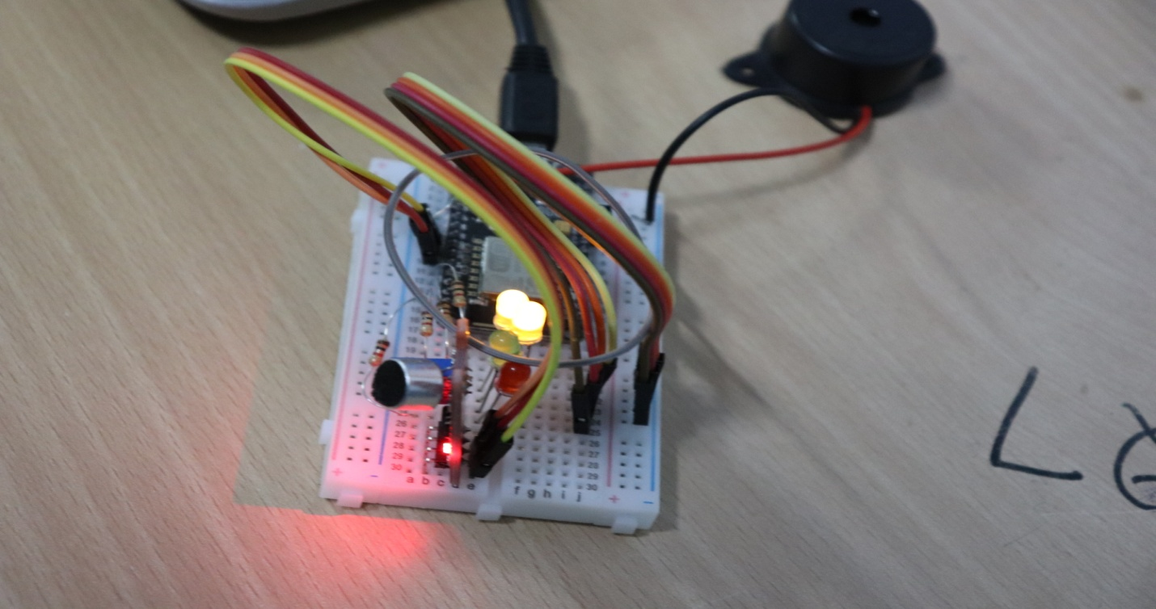

**Fig.5.3.When second whistle is detected**

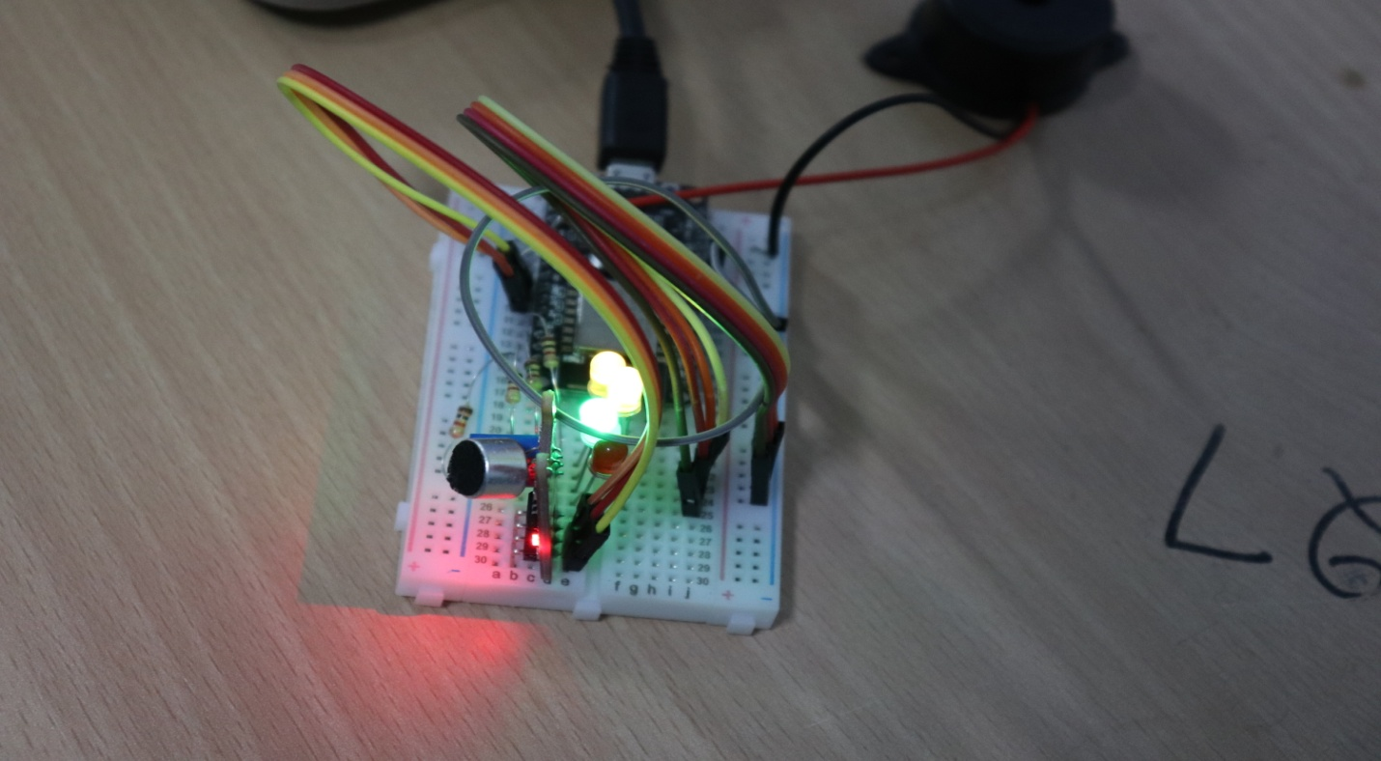

**Fig.5.4.When third whistle is detected**

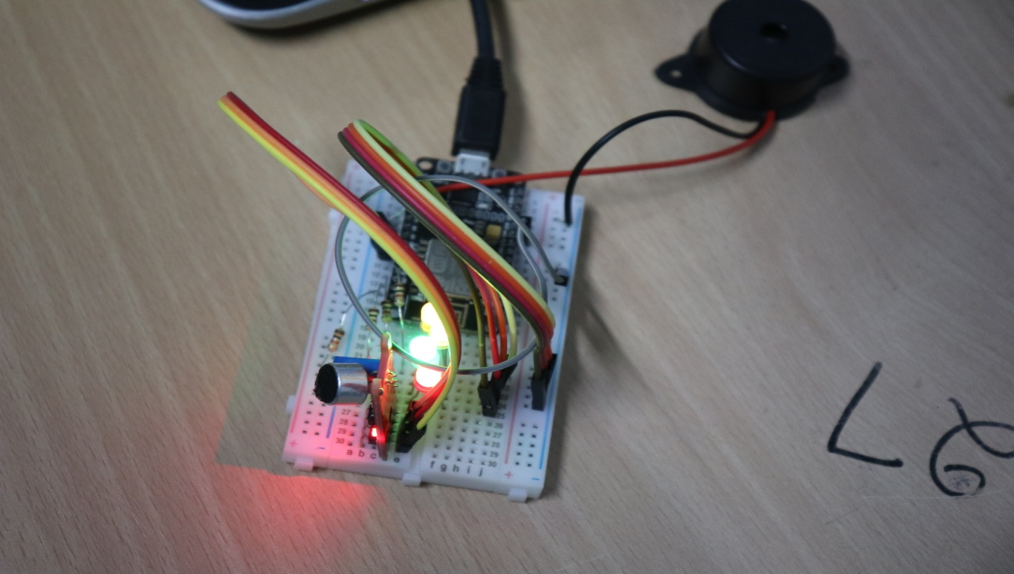

**Fig.5.5 After the last whistle, the buzzer activates**

**CHAPTER-6**

**CONCLUSIONS AND FUTURE ENHANCEMENTS**

**6.1. CONCLUSIONS**

For the respective whistle count the respective LED glows, and for the last whistle the buzzer activates and warns us. Thus there would be no distraction while doing any work and can switch off the stove when the last whistle has blown i.e when the buzzer blown.

**6.2. FUTURE ENHANCEMENTS**

Pressure cooker whistle sensor system is just a prototype model sensor with the FOUR (4) resistors and (4) LED’S and LED light glow indicates whistle count of pressure cooker. The buzzer makes a sound after 3 whistles occur. We would like to enhance it in future by developing the actual model of this prototype. Also this can be improved to be linked with any other systems. Pressure cooker whistle sensor is efficient and user friendly. In future we can make it more easy removing LEDS and lets make system in such a way it checks the cooker temperature and indicate buzzer and terminate system without man power.

**REFERENCES**

[1] https://www.arduino.cc/en/Main/Software

[2] http://www.instructables.com/id/Quick-Start-to-Nodemcu-ESP8266-on-Arduino-IDE/

[3] https://nodemcu.readthedocs.io/en/master/en/modules/gpio/

[4] http://www.instructables.com/id/Arduino-Sound-Sensor-with-LED/

[5] https://namespace-gowtham.com/2017/03/14/blinking-external-led-using-esp8266-nodemcu/

[6] http://www.instructables.com/id/Control-LED-Using-PushButton-With-NodeMCU/

[7] http://www.instructables.com/id/Internet-Controlled-LED-Using-NodeMCU/

[8] https://github.com/squix78/esp8266-fritzing-parts/tree/master/nodemcu-v1.0

[9] https://iot-playground.com/blog/2-uncategorised/38-esp8266-and-arduino-ide-blink-example